W04 Team Activity – Foundation Program Design

Foundation Program #1: Abstraction with YouTube Videos

1. Classes and Responsibilities
- Video
  - Store the main information of a YouTube video:
    - title
    - author
    - length in seconds
  - Store and manage a list of comments related to the video
  - Provide the number of comments
  - Display all video information, including comments
- Comment
  - Store the name of the person who wrote the comment
  - Store the text of the comment
  - Provide access to this information

2. Methods
- Video
  - Video(string title, string author, int lengthSeconds)
    - Constructor. Initializes the video with a title, author, and length. It also initializes the internal list of comments.
  - AddComment(Comment comment)
    - Adds a Comment object to the _comments list.
  - GetCommentCount()
    - Returns the number of comments as an int.
  - DisplayInfo()
    - Displays the video information and then all the comments.
- Comment
  - Comment(string authorName, string text)
    - Constructor. Initializes the comment with the author name and the text.
  - GetAuthorName()
    - Returns the _authorName.
  - GetText()
    - Returns the comment text.
3. Member Variables
- Video
  - _title : string
  - _author : string
  - _lengthSeconds : int
  - _comments : List<Comment>
- Comment
  - _authorName : string
  - _text : string

4. Class Diagram
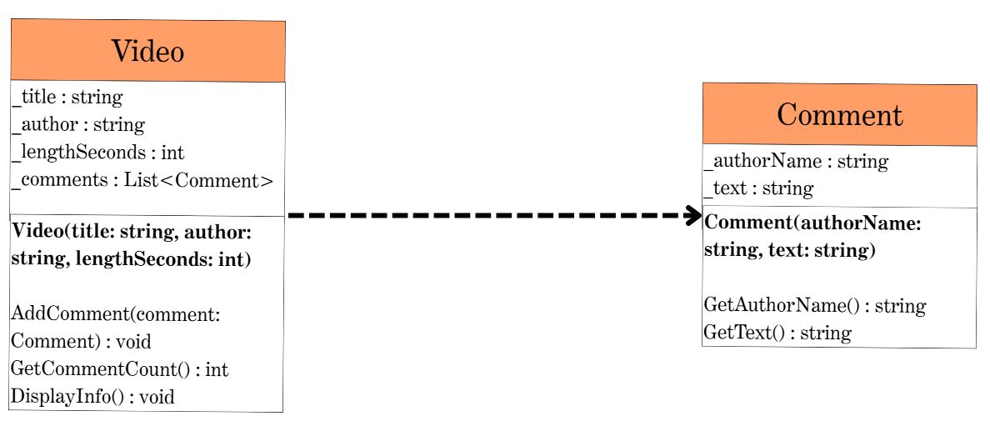
5. Program Flow
- The program starts in Main() and creates several Video objects by calling the Video constructor with a title, an author, and a length in seconds.
- For each video, the program creates several Comment objects using the Comment constructor, passing the author name and the text of the comment.
- Each Comment is added to a video by calling AddComment(comment) on the corresponding Video object.
- All Video objects are stored in a List<Video>.
- The program iterates through the list of videos. For each video:
  - It calls DisplayInfo().
  - Inside DisplayInfo(), the video prints its _title, _author, _lengthSeconds, and the result of GetCommentCount().
  - Then it loops over _comments and uses GetAuthorName() and GetText() on each Comment to display them.

Foundation Program #2: Encapsulation with Online Ordering

1. Classes and Responsibilities
- Order
  - Contain a list of products.
  - Contain a customer.
  - Calculate the total cost of the order.
  - Return a packing label containing:
    - product name
    - product ID
  - Return a shipping label containing:
    - customer name
    - complete address
  - Apply shipping rules:
    - $5 if the customer lives in the USA
    - $35 if the customer does NOT live in the USA
- Product
  - Store name of product.
  - Store unique product ID.
  - Store price per unit.
  - Store quantity purchased.
  - Compute total cost: price * quantity.
- Customer
  - Store customer name.
  - Store an Address object.
  - Method to determine whether the customer lives in the USA (delegates to Address).
- Address
  - Store:
    - street
    - city
    - state/province
    - country
  - Determine if the country is the USA.
  - Return the full address as a formatted string.
2. Methods
- Order
  - Order(Customer customer)
    - Constructor. Initializes the customer and the internal list of products.
  - AddProduct(Product product)
    - Adds a product to the internal list.
  - GetTotalPrice()
    - Computes:
      - sum of each product total
      - plus shipping cost ($5 or $35)
  - GetPackingLabel()
    - Returns a multiline string listing product name and product ID.
  - GetShippingLabel()
    - Returns a multiline string with the customer name and address.
- Product
  - Product(string name, string productId, double price, int quantity)
    - Constructor.
  - GetTotalCost()
    - Returns price * quantity.
  - Getters as needed for name and product ID.
- Customer
  - Customer(string name, Address address)
    - Constructor.
  - LivesInUSA()
    - Returns true/false by calling the Address method.
  - Getters for customer name.
- Address
  - Address(string street, string city, string state, string country)
    - Constructor.
  - IsUSA()
    - Returns true if country == "USA".
  - GetFullAddress()
    - Returns street, city, state, and country as formatted string.
3. Member Variables
- Order
  - _customer : Customer
  - _products : List<Product>
- Product
  - _name : string
  - _productId : string
  - _price : double
  - _quantity : int
- Customer
  - _name : string
  - _address : Address
- Address
  - _street : string
  - _city : string
  - _state : string
  - _country : string

4. Class Diagram
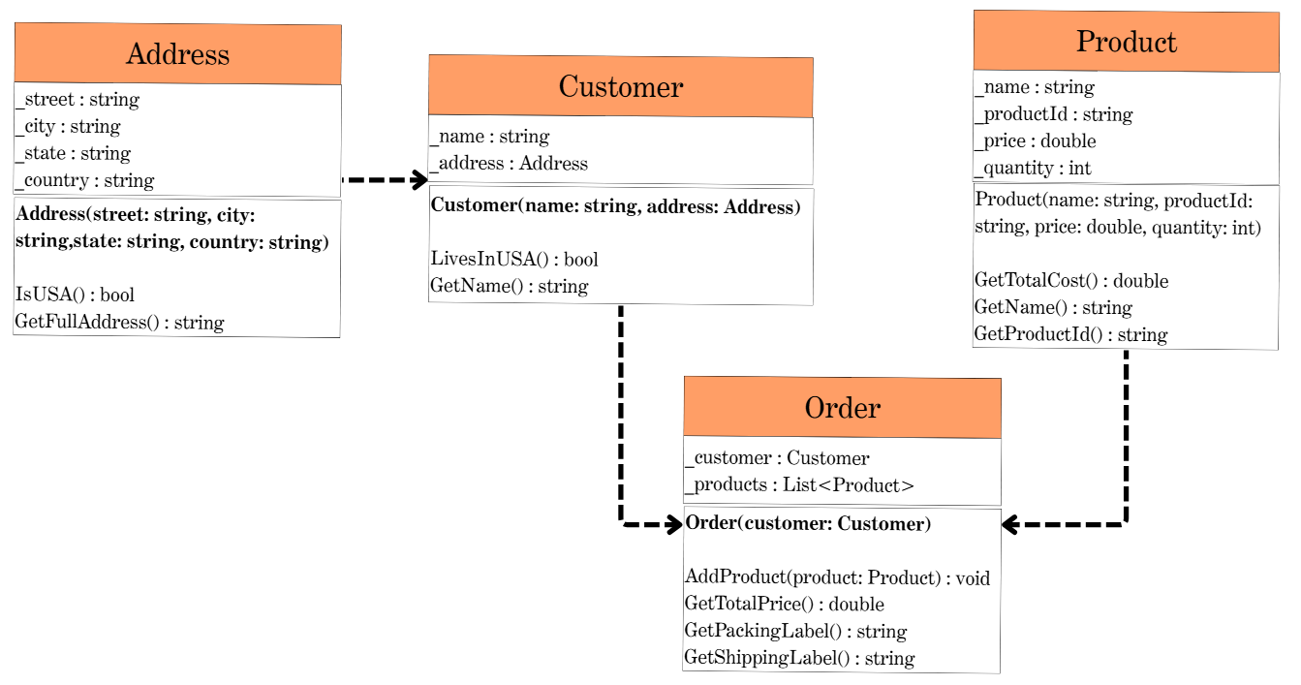
5. Program Flow
- The program begins in Main() and creates an Address object.
- A Customer object is created with the address.
- Multiple Product objects are created using the constructor.
- An Order object is created and products are added via AddProduct().
- The program creates at least 2 different orders, each with 2–3 products.
- For each order:
  - Display the packing label using GetPackingLabel().
  - Display the shipping label using GetShippingLabel().
  - Compute the total price using GetTotalPrice().
  - The program ends after printing all labels and totals.

